[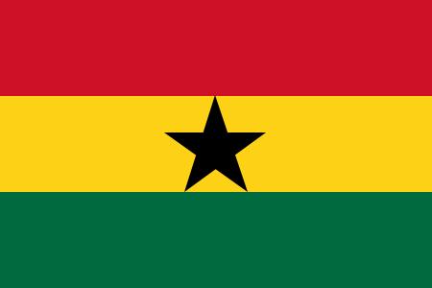](http://upload.wikimedia.org/wikipedia/commons/1/19/Flag_of_Ghana.svg)[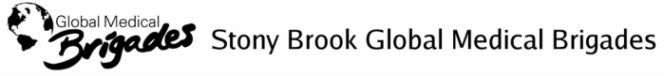](http://stonybrookgmb.weebly.com/)

[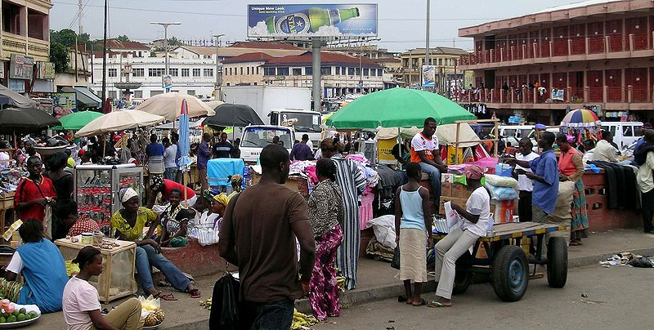](http://upload.wikimedia.org/wikipedia/commons/8/83/Rue_du_centre_Kumasi.jpg)[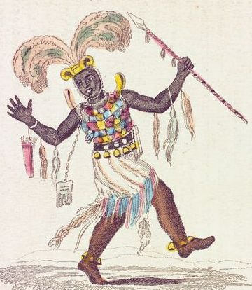](http://upload.wikimedia.org/wikipedia/en/6/67/Ashanteewarcaptain.jpg)**GHANA** History & Culture

The Ghanian flag (1957): the red represents the blood that was shed towards independence, the gold represents the mineral wealth of Ghana, the green symbolizes the rich agriculture, and the black star is the symbol of African emancipation

24 million people; 45% are AKAN; 52 total ethnic groups; official language English (or Fanti); 69% Christian, 16% Muslim, 6% no religion.

Ashanti War Captain (1701-1896)

[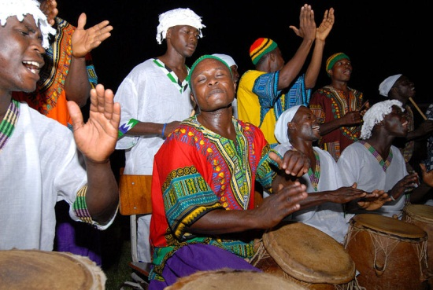](http://upload.wikimedia.org/wikipedia/commons/8/8c/Dashiki_and_kufi.jpg)[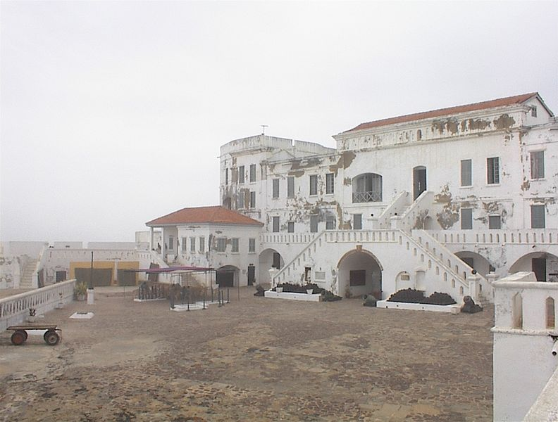](http://upload.wikimedia.org/wikipedia/commons/3/3d/Cape_coast_castle_II.JPG)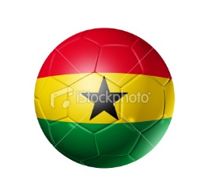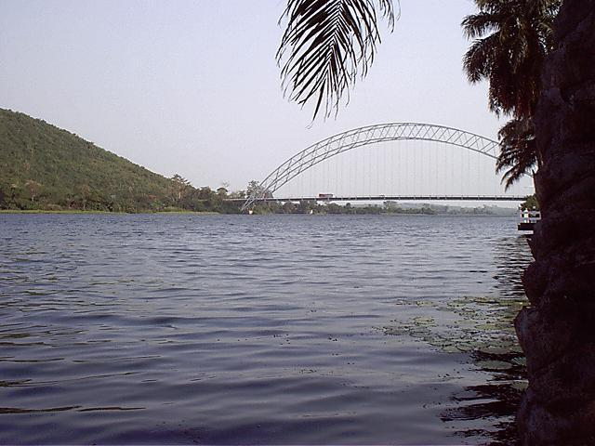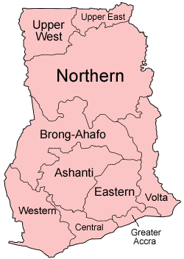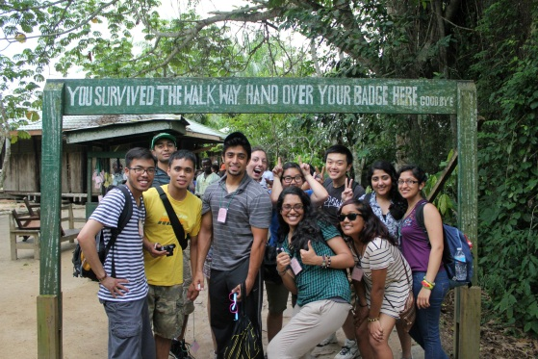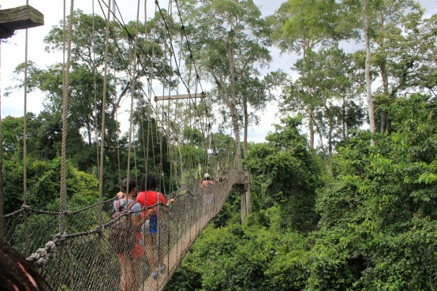

Music/Dance: varies between ethnic groups; Afro-jazz; 1990s ‘Hiplife’ a mix of Afro-reggae, dancehall, hiphop. LOOK UP LAPAS TOYOTA & Sarkodie

Cape Coast Castle: A slave trading castle

Lake Volta: largest reservoir in the world!

Kakum National Park (7 bridges, 1080ft, 130ft high)